Oracle Database Upgrade – from 11.2.0.3 to 12c

As per Target, user needs to choose “Upgrade Oracle Database“

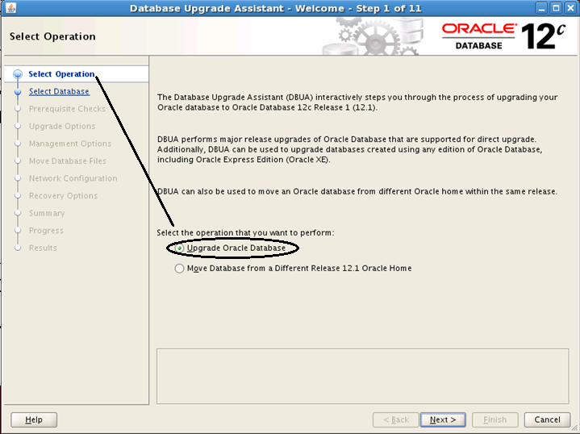

Double Check source and target are correct. User may need to modify /etc/oratab file, if entry is not being populated

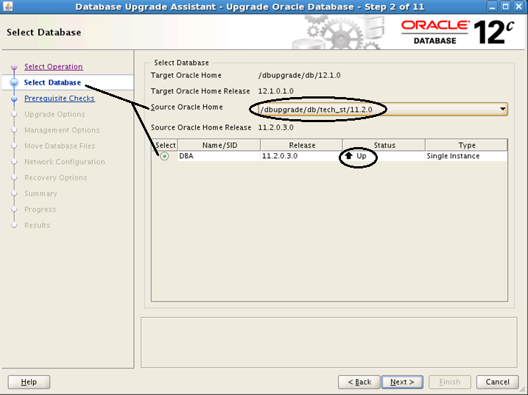

Prerequisite checks are being performed.

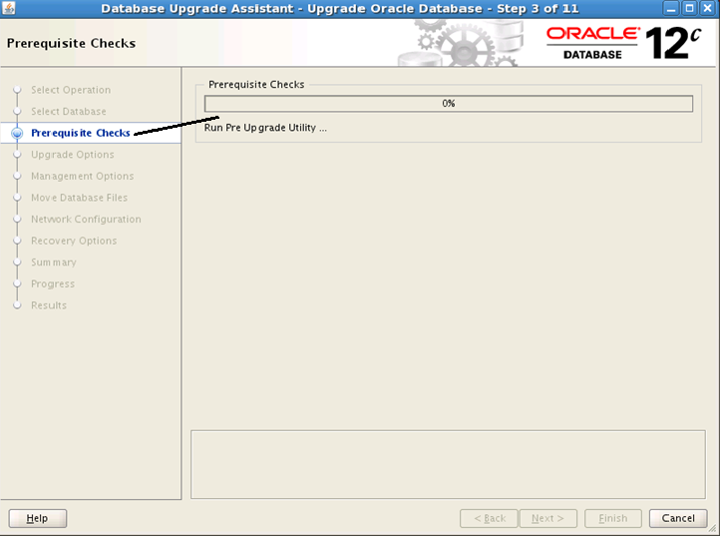

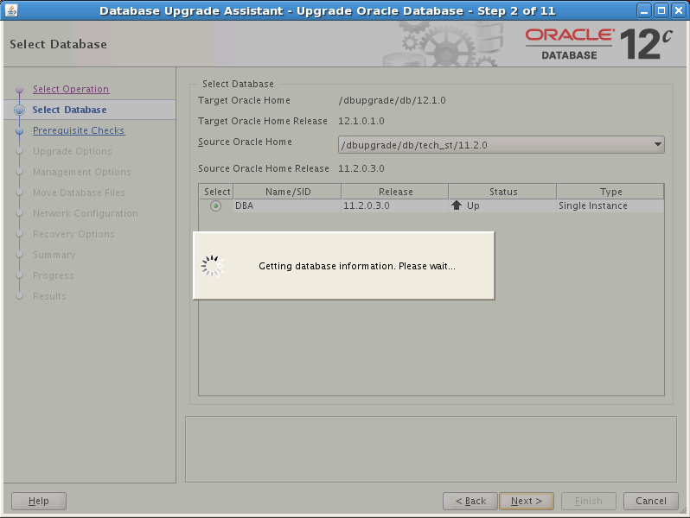

Here user can see over all prerequisite checks and status. Prerequisite may be fixable by system and for this just choose the “Action : Fix – Pre Upgrade” and “Apply Action”.
Prior to proceed, it is recommended to check rest of pre-requisites and take required action.

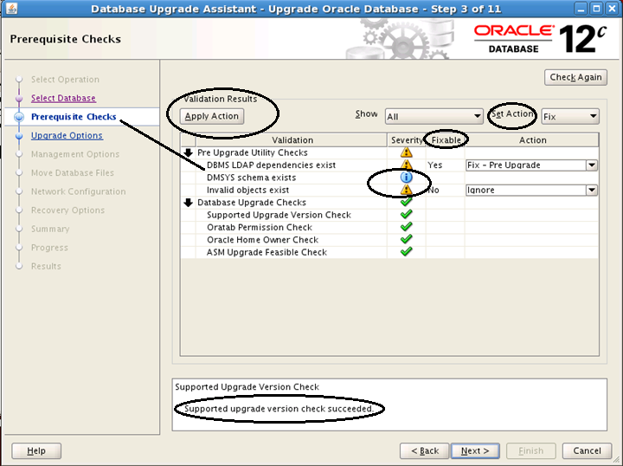

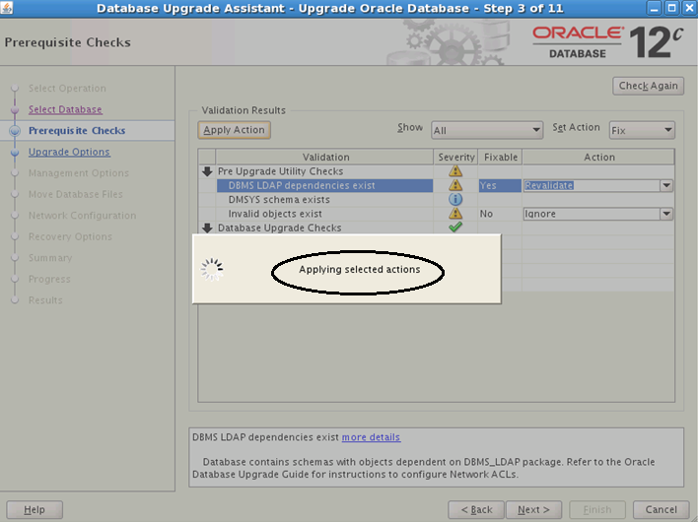

As a part of Upgrade, user can optionally choose “Recompile Invalid Objects during Post Upgrade”.
I would strongly recommend to perform “Gather Statistics” manually prior to start Upgrade.

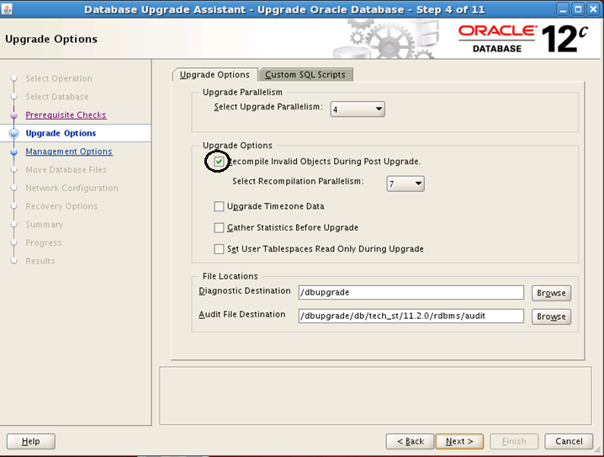

If “EM Cloud Central” is not configured, user may select “Configure Enterprise Manager Database Express” option but in order to minimize downtime, user may ignore it and later one this configuration can be done manually.

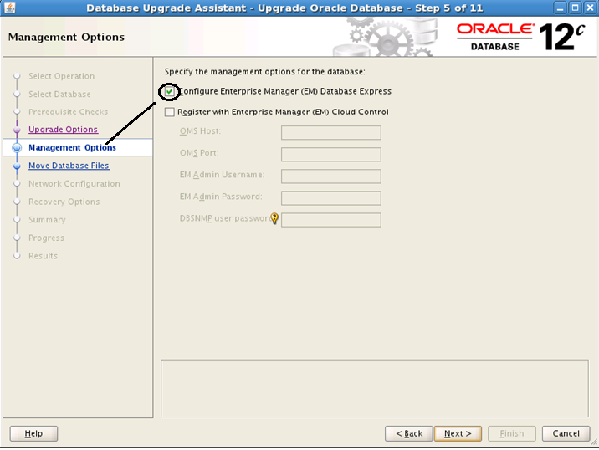

If required, Database Files can be moved as a part of Upgrade but it is advisable to perform this activity subsequent to successful upgrade.

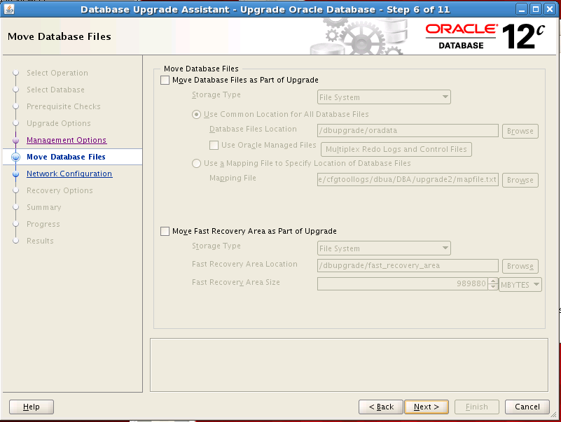

User has to select Listener, where upgraded database is supposed to register with.

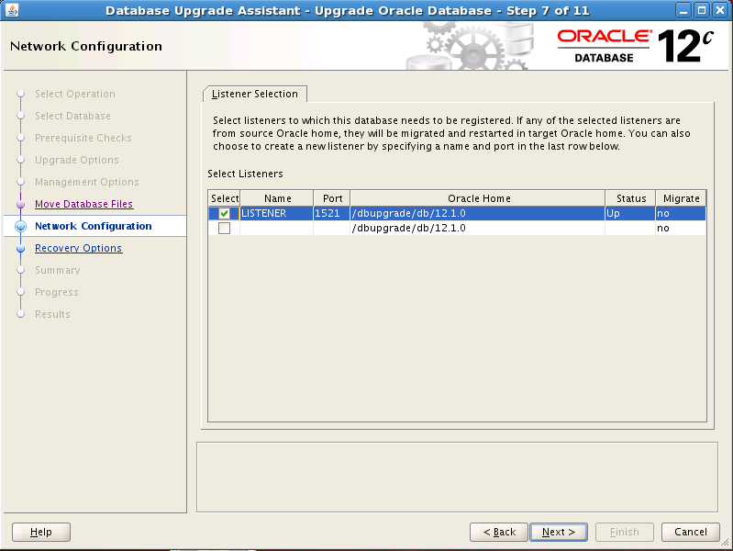

This is highly recommended to take backup before starting Upgrade.

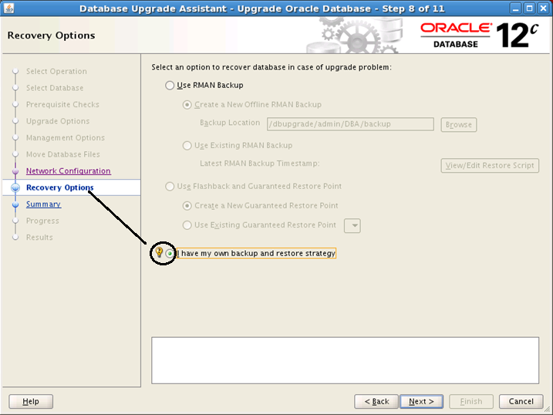

Review the Upgrade summary.

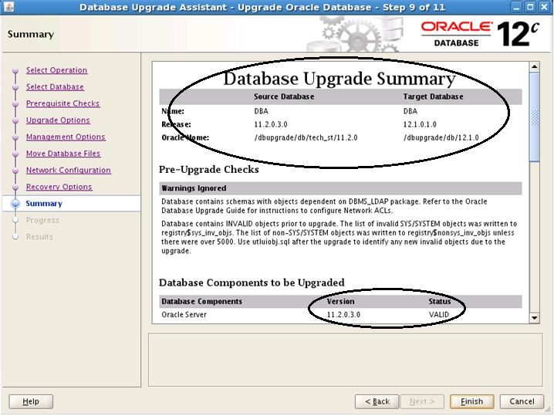

“Activity Log” can also be reviewed during Upgrade.

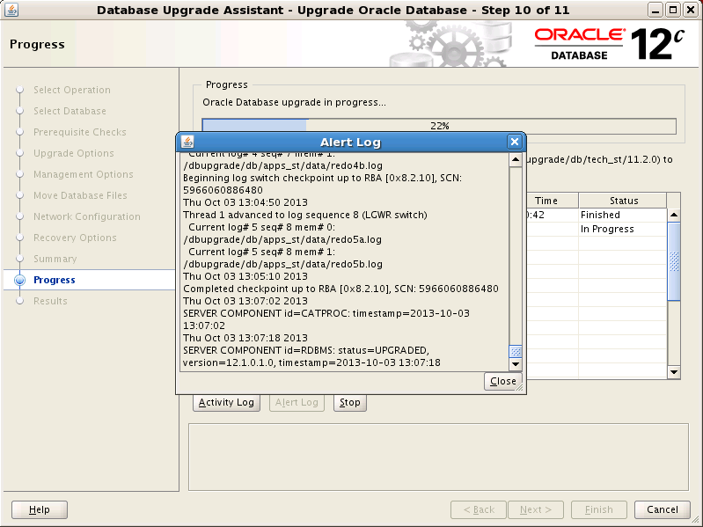

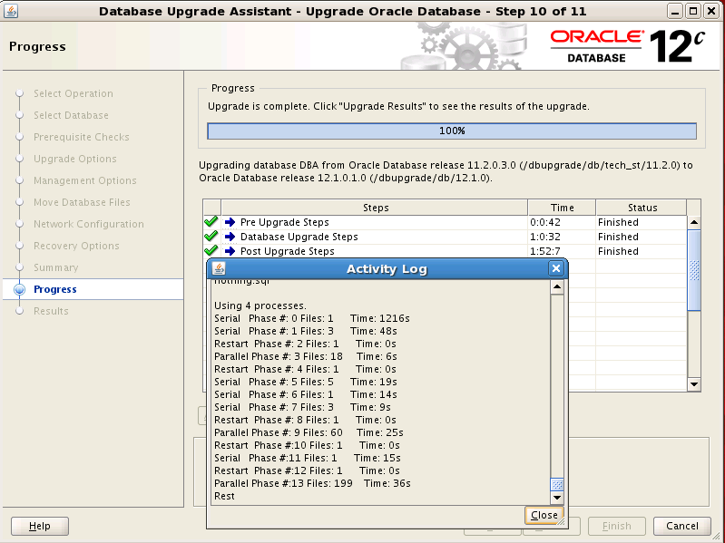

When upgrade is completed, check overall status and Invalid Objects.

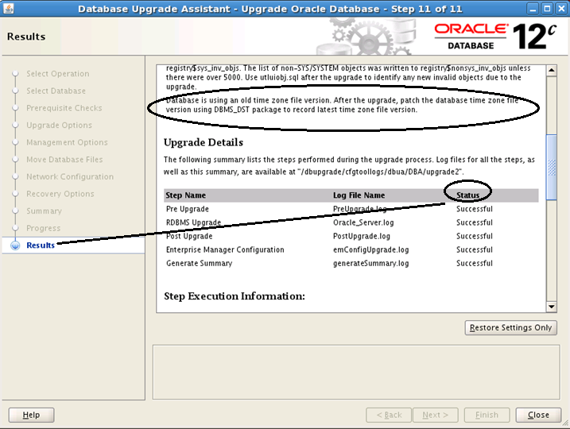

DBA_Registry should also be checked to be sure that Upgrade is successful.

Oracle Real Application Clusters | 12.1.0.1.0 | OPTION OFF | 03-OCT-2013 13:20:09
Oracle Text | 12.1.0.1.0 | VALID | 03-OCT-2013 15:28:10
Oracle Multimedia | 12.1.0.1.0 | VALID | 03-OCT-2013 15:28:11
Oracle Database Catalog Views | 12.1.0.1.0 | VALID | 03-OCT-2013 15:28:05
Oracle OLAP API | 12.1.0.1.0 | VALID | 03-OCT-2013 15:28:14
JServer JAVA Virtual Machine | 12.1.0.1.0 | VALID | 03-OCT-2013 15:28:07
Oracle Database Java Packages | 12.1.0.1.0 | VALID | 03-OCT-2013 15:28:08
Oracle XDK | 12.1.0.1.0 | VALID | 03-OCT-2013 15:28:09
OLAP Analytic Workspace | 12.1.0.1.0 | VALID | 03-OCT-2013 15:28:13
Oracle XML Database | 12.1.0.1.0 | VALID | 03-OCT-2013 15:28:20
Spatial | 12.1.0.1.0 | VALID | 03-OCT-2013 15:28:12
Oracle Database Packages and Types | 12.1.0.1.0 | VALID | 03-OCT-2013 15:28:06

Here Upgrade is completed. Now perform Post Upgrade activities (such as Post-requisite of Applied Patches and DST - Time zone Upgrade etc.) following relevant documents.

